ASP.NET Project Proposal

Team Members: Alex Poole, Derek Casey

FitHub Project Outline

Design a workout planner website with a database of exercises where users can create their own workout plans and customize exercises. A workout would be the personal user’s use of an exercise and would include information such as the number of sets and repetitions. A workout plan would be a user’s personal list of saved and customized workouts. May potentially calculate user’s one rep max every time a set of an exercise is complete and Body Mass Index (BMI).

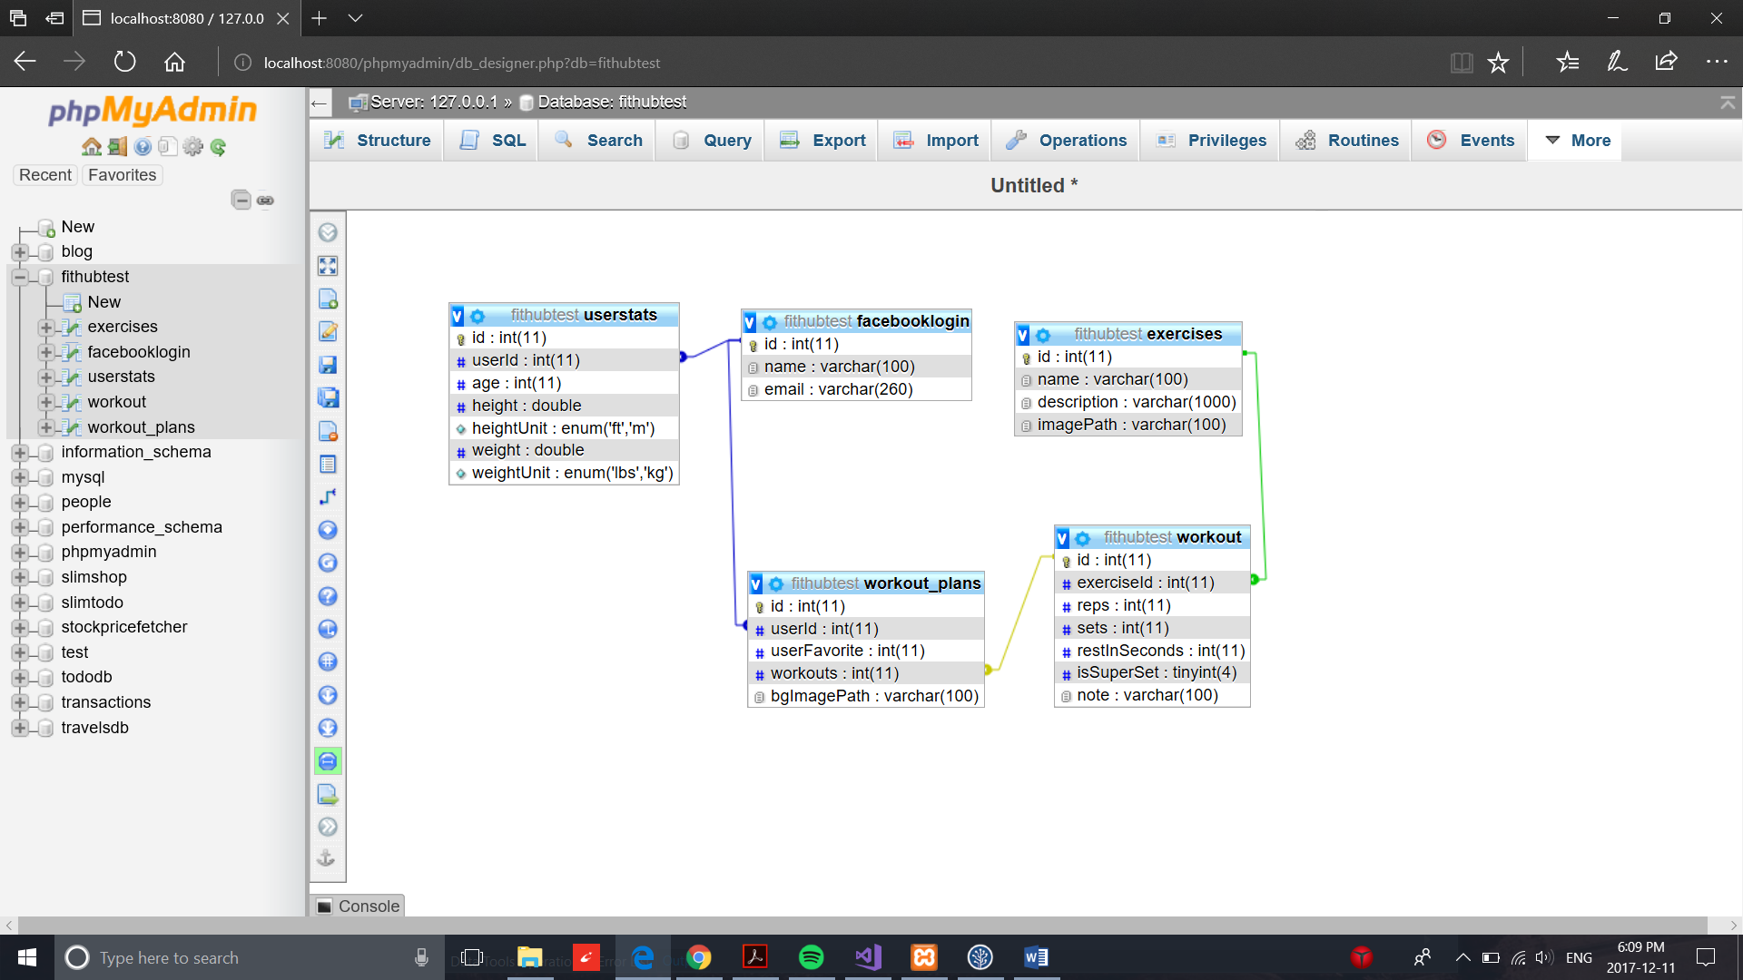

**Task Separation**

Derek: Facebook Login, CRUD and UI for workout plans table, user stats table

Alex: CRUD and UI for workout, CRUD and UI for exercise